**Instructions for PlayPolo App Use**

1. Download the PlayPolo App on your iPhone or Android (scan this QR Code).
2. Select ‘Search for your Club App’.

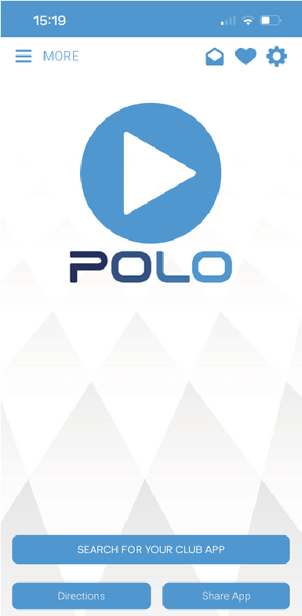

1. Enter ‘Schools & Universities Polo Association’ into the Search Bar and select the ribbon.

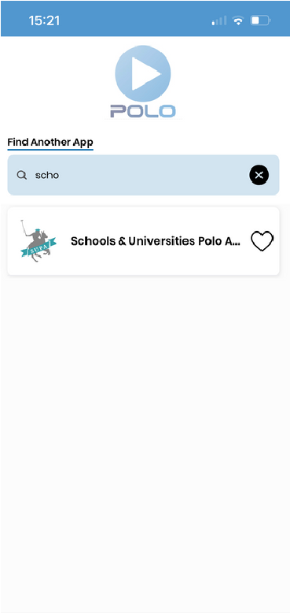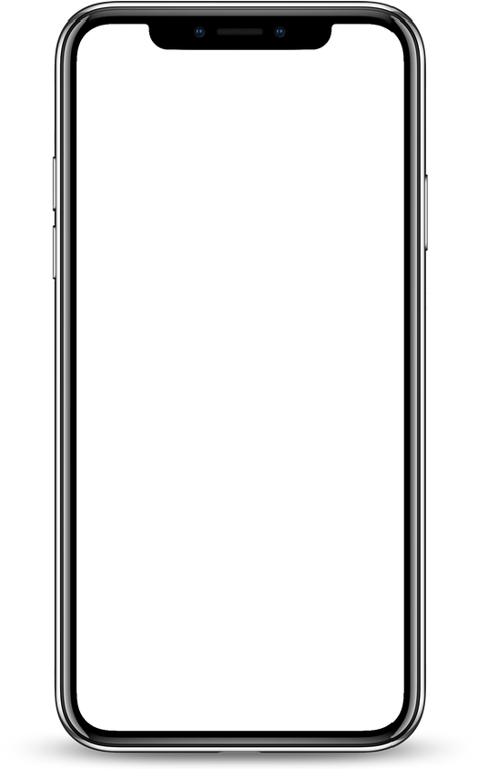

1. Select the ‘Menu’ Icon in the top-left hand corner.

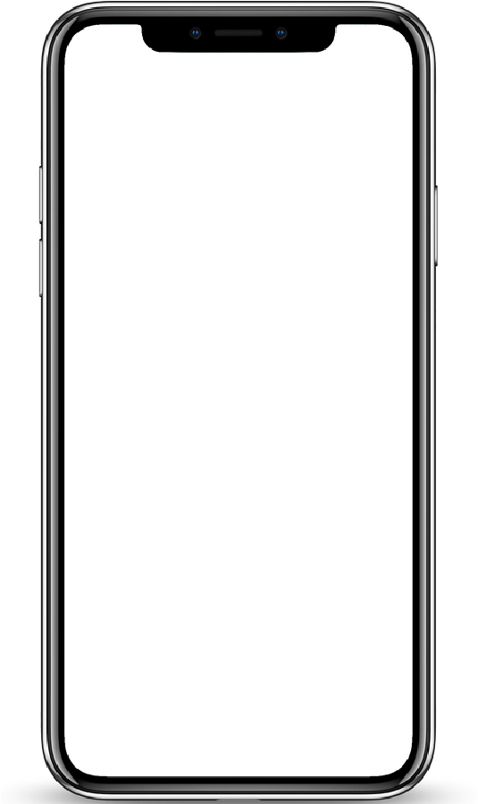

1. Select ‘Schools Friendly’ from the sidebar.

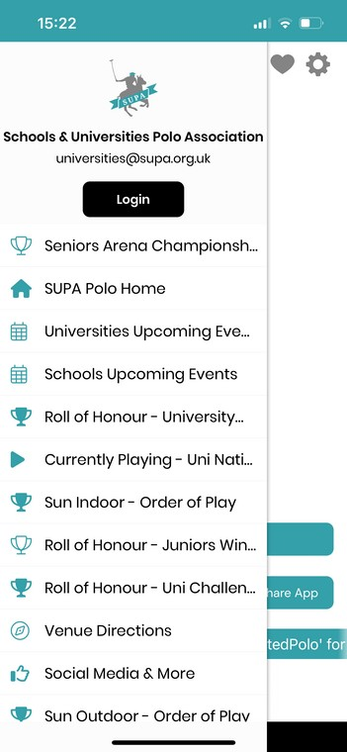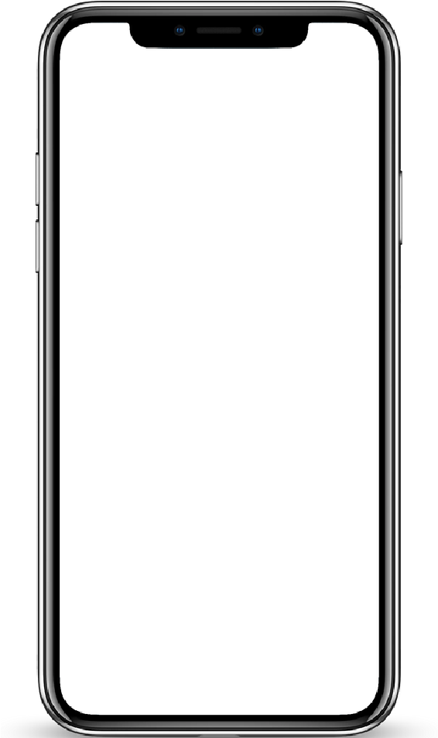

1. Select the ‘My Team’ icon to view playing times for your team and results.

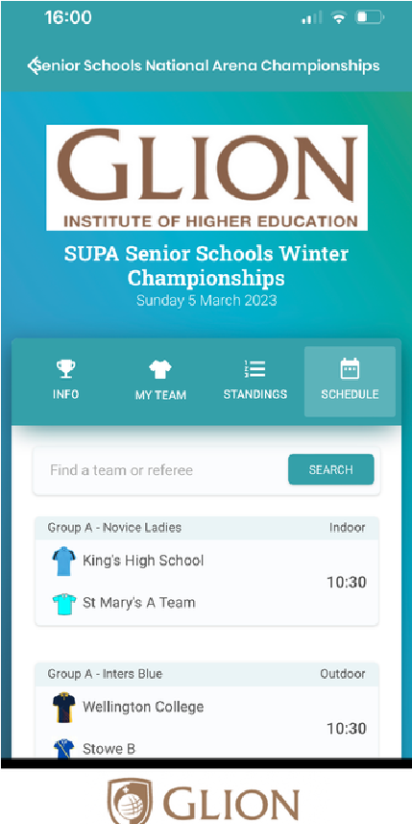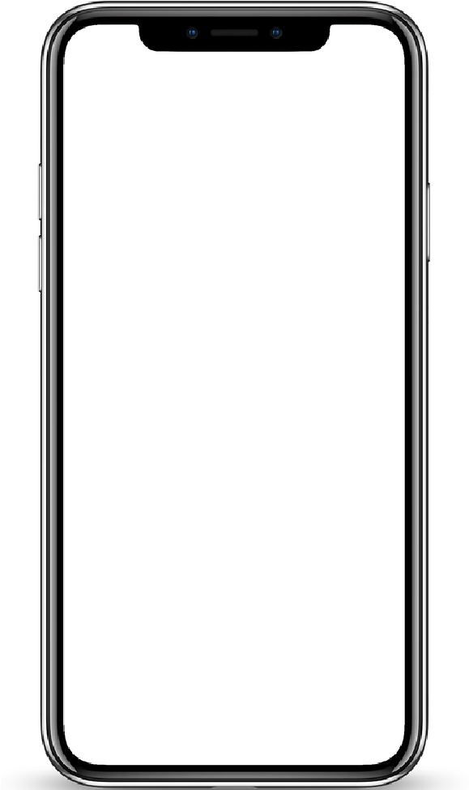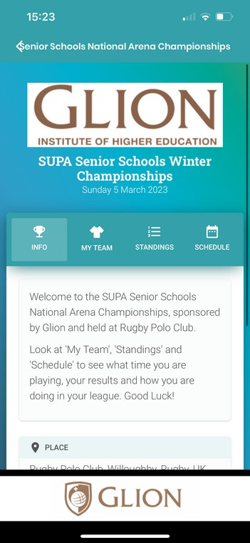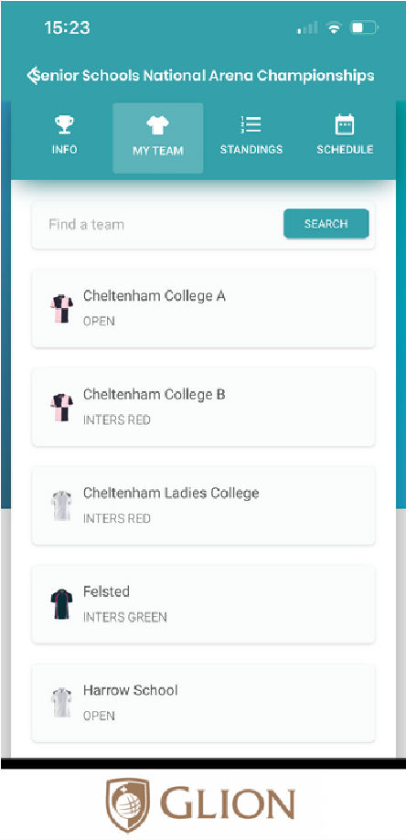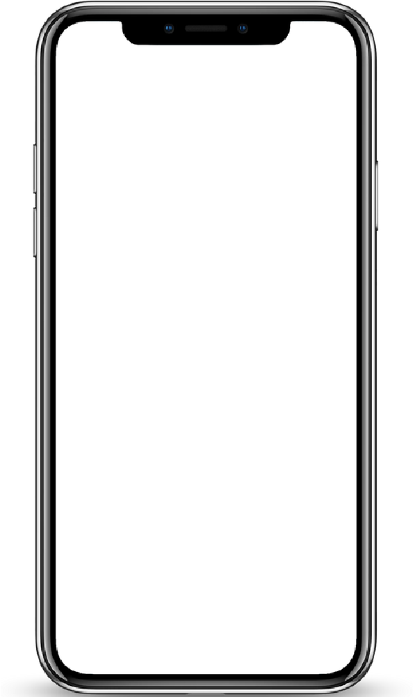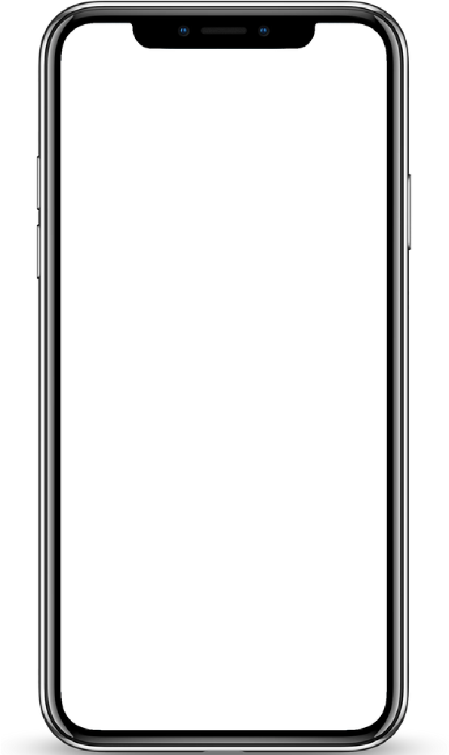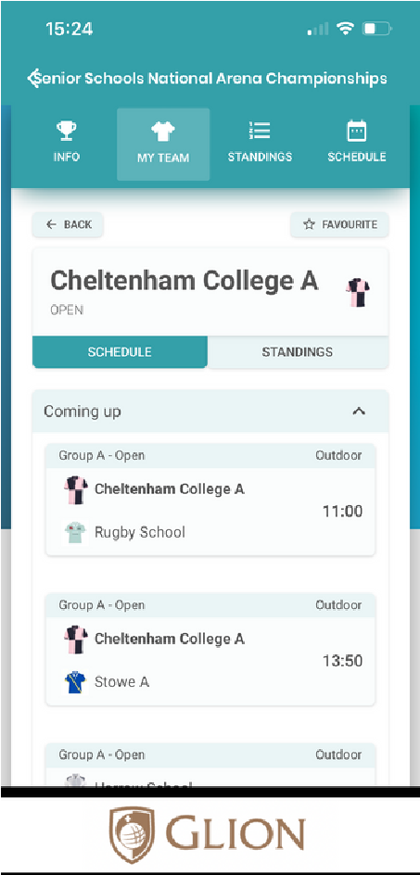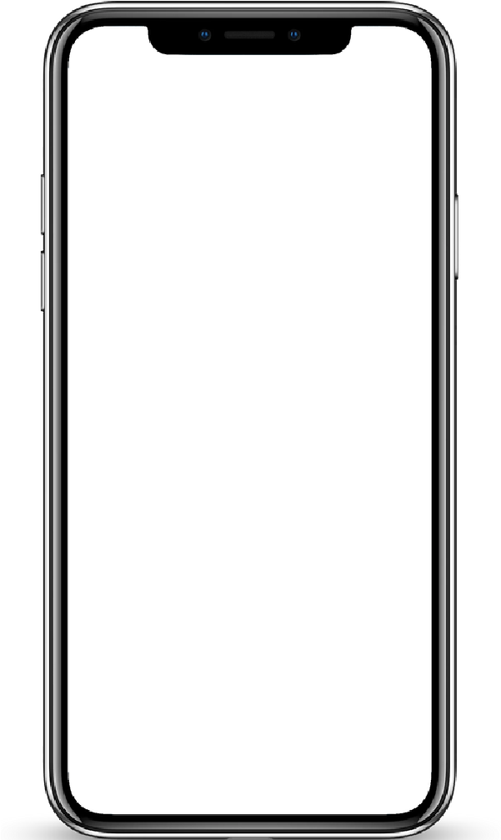

Clicking 'My Team' will show you all the teams playing in the Tournament. Select your team (here it's Cheltenham College A) and players and spectators can view what time their team are playing, and once they've played it will display their results immediately after each chukka.

1. View ‘Schedule’ to see the running order and results for the whole tournament.
2. View ‘Standings’ to view how your team is doing in your league.

